**Large ferroelectric polarization of TiN/Hf0.5Zr0.5O2/TiN capacitors due to stress-induced crystallization at low thermal budget**   
Si Joon Kim[, Dushyant Naray](http://aip.scitation.org/author/Lucero%2C+Antonio+T)[a](http://aip.scitation.org/author/Narayan%2C+Dushyant)[n, Jae-Gil Lee,](http://aip.scitation.org/author/Young%2C+Chadwin+D) [Jaidah Mohan](http://aip.scitation.org/author/Mohan%2C+Jaidah)[,](http://aip.scitation.org/author/Summerfelt%2C+Scott+R) [Joy S. Lee](http://aip.scitation.org/author/Lee%2C+Joy+S)[, Jaebeom](http://aip.scitation.org/author/San%2C+Tamer) [L](http://aip.scitation.org/author/Lee%2C+Jaebeom)[ee, Harrison S](http://aip.scitation.org/author/Colombo%2C+Luigi). Kim, [Young-](http://aip.scitation.org/author/Byun%2C+Young-Chul)[Chu](http://aip.scitation.org/author/Kim%2C+Jiyoung)[l Byun,](http://aip.scitation.org/author/Kim%2C+Si+Joon) [Antonio T. Lucero](http://aip.scitation.org/author/Lucero%2C+Antonio+T)[,](http://aip.scitation.org/author/Narayan%2C+Dushyant) [Chadwin D. You](http://aip.scitation.org/author/Young%2C+Chadwin+D)[ng, Scott R. S](http://aip.scitation.org/author/Mohan%2C+Jaidah)[u](http://aip.scitation.org/author/Summerfelt%2C+Scott+R)[mmerfelt,](http://aip.scitation.org/author/Lee%2C+Joy+S) [Tamer San](http://aip.scitation.org/author/San%2C+Tamer)[,](http://aip.scitation.org/author/Lee%2C+Jaebeom) [Luigi Colombo](http://aip.scitation.org/author/Colombo%2C+Luigi)[, and](http://aip.scitation.org/author/Kim%2C+Harrison+S) [J](http://aip.scitation.org/author/Kim%2C+Jiyoung)[iyoung](http://aip.scitation.org/author/Byun%2C+Young-Chul) [Kim](http://aip.scitation.org/author/Kim%2C+Jiyoung)

Citation: Appl. Phys. Lett.**111**, 242901 (2017);   
View online: <https://doi.org/10.1063/1.4995619>  
View Table of Contents: <http://aip.scitation.org/toc/apl/111/24>Published by the [American Institute of Physics](http://aip.scitation.org/publisher/)

**Articles you may be interested in**   
[Tailoring magnetic skyrmions by geometric confinement of magnetic structures](http://aip.scitation.org/doi/abs/10.1063/1.5005904)   
[Applied Physics Letters](http://aip.scitation.org/doi/abs/10.1063/1.5005904) **[111](http://aip.scitation.org/doi/abs/10.1063/1.5005904)**[, 242405 (2017); 10.1063/1.5005904](http://aip.scitation.org/doi/abs/10.1063/1.5005904)   
[Coexistence of non-volatile bi-polar resistive switching and tunneling magnetoresistance in spatially confined La0.3Pr0.4Ca0.3MnO3 films](http://aip.scitation.org/doi/abs/10.1063/1.5001710)   
Applied Physics Letters **111**, 242401 (2017); 10.1063/1.5001710   
[Integrated light-sheet imaging and flow-based enquiry (iLIFE) system for 3D in-vivo imaging of multicellular organism](http://aip.scitation.org/doi/abs/10.1063/1.5009782)   
[Applied P](http://aip.scitation.org/doi/abs/10.1063/1.5009782)hysics Letters **111**, 243702 (2017); 10.1063/1.5009782  
 [Ferroelectric, pyroelectric, and piezoelectric properties of a photovoltaic perovskite oxide](http://aip.scitation.org/doi/abs/10.1063/1.4974735)   
[Applied Physics Letters](http://aip.scitation.org/doi/abs/10.1063/1.4974735) **[110](http://aip.scitation.org/doi/abs/10.1063/1.4974735)**[, 063903 (2017); 10.1063/1.4974735](http://aip.scitation.org/doi/abs/10.1063/1.4974735)   
[Spontaneous micro-modification of single-layer graphene induced by femtosecond laser irradiation Applied Physics Letters](http://aip.scitation.org/doi/abs/10.1063/1.4997343) **[111](http://aip.scitation.org/doi/abs/10.1063/1.4997343)**[, 241901 (2017); 10.1063/1.4997343](http://aip.scitation.org/doi/abs/10.1063/1.4997343)   
[Cell micro-irradiation with MeV protons counted by an ultra-thin diamond membrane](http://aip.scitation.org/doi/abs/10.1063/1.5009713)   
[Applied Physics Letters](http://aip.scitation.org/doi/abs/10.1063/1.5009713) **[111](http://aip.scitation.org/doi/abs/10.1063/1.5009713)**[, 243701 (2017); 10.1063/1.5009713](http://aip.scitation.org/doi/abs/10.1063/1.5009713)



APPLIED PHYSICS LETTERS 111, 242901 (2017) 

[Large ferroelectric polarization of TiN/Hf0.5Zr0.5O2/TiN capacitors due](https://doi.org/10.1063/1.4995619)

[to stress-induced crystallization at low thermal budget](https://doi.org/10.1063/1.4995619)

Si Joon Kim,1Dushyant Narayan,1Jae-Gil Lee,1Jaidah Mohan,1Joy S. Lee,1 Jaebeom Lee,1Harrison S. Kim,1Young-Chul Byun,1Antonio T. Lucero,1 Chadwin D. Young,1Scott R. Summerfelt,2Tamer San,2Luigi Colombo,2 and Jiyoung Kim1,a)   
1Department of Materials Science and Engineering, The University of Texas at Dallas,

800 West Campbell Road, Richardson, Texas 75080, USA   
2Texas Instruments, 13121 TI Blvd, Dallas, Texas 75243, USA

(Received 12 July 2017; accepted 26 November 2017; published online 12 December 2017)

We report on atomic layer deposited Hf0.5Zr0.5O2 (HZO)-based capacitors which exhibit excellent ferroelectric (FE) characteristics featuring a large switching polarization (45 lC/cm2) and a low FE

saturation voltage (�1.5 V) as extracted from pulse write/read measurements. The large FE polarization in HZO is achieved by the formation of a non-centrosymmetric orthorhombic phase,

which is enabled by the TiN top electrode (TE) having a thickness of at least 90 nm. The TiN films are

deposited at room temperature and annealed at 400�C in an inert environment for at least 1 min in a

rapid thermal annealing system. The room-temperature deposited TiN TE acts as a tensile stressor on

the HZO film during the annealing process. The stress-inducing TiN TE is shown to inhibit the forma-

tion of the monoclinic phase during HZO crystallization, forming an orthorhombic phase that gener-

ates a large FE polarization, even at low process temperatures. Published by AIP Publishing.

<https://doi.org/10.1063/1.4995619>

Ferroelectricity has been studied intensively for non-volatile semiconductor device applications such as ferroelec-tric random access memory (FRAM) and ferroelectric (FE) field-effect transistor (FFET) over the past few decades.1–5 FRAM has several notable advantages over the current flash memory standard including low voltage/low power opera-tions (1.5 V vs. >10 V), fast writes (�50 ns vs. �1 ms), an infinite number of writes (1015cycles vs 105cycles), and a simplified process flow.2–5Most of the previous research has focused on electronic devices using conventional ferroelec-tric (FE) materials such as Pb(Zr,Ti)O3 (PZT), BaTiO3 (BTO), and SrBi2Ta2O9 (SBT).1–4These FE films are depos-ited at high temperatures or require a high temperature annealing process (600�C or higher) to achieve the appropri-ate non-centrosymmetric perovskite phase or layered perov-skite phase. Consequently, FE circuits are integrated at the front-end process with minimum unit cell areas of 6F2, where F is the minimum feature size. Today, embedded pla-nar capacitor FRAM cells using PZT are integrated in com-plementary metal oxide semiconductor (CMOS) flow at the 130 nm node. However, as these devices scale, there will be a need to transition from planar capacitors to three-dimensional capacitors. Current FE materials are difficult to scale down in thickness due to a relatively small bandgap (about 3–4 eV), resulting in higher leakage current and elec-trical breakdown. In addition, their multicomponent nature makes it difficult to deposit the films on three-dimensional structures, thus making scaling difficult. Up to now, a 70-nm-thick PZT film has been used to make commercially available 1.5 V FRAM devices.3–5   
 Recently, ferroelectricity in very thin doped-HfO2 films (�10 nm) was reported.6Hf-based dielectrics have been now

a)Electronic mail: [jiyoung.kim@utdallas.edu](mailto:jiyoung.kim@utdallas.edu)

used in the industry as gate dielectrics for over one decade. The advantage that these materials pose is that they can be easily deposited by atomic layer deposition (ALD) and as a result has generated great interest as a substitute element to conventional PZT FE materials.5–9The FE behavior of these doped-HfO2 films is believed to originate from the non-centrosymmetric orthorhombic phase (o-phase, space group: Pca21), which requires large tensile strain (about 3–5 GPa) to crystallize.10–12To induce the formation of the o-phase, most researchers have adopted high temperature (>650�C) treatment methods for generating stresses in the film.6–8This high thermal budget process for doped-HfO2 FE films pre-cludes the integration of FE circuits in the back-end of line (BEOL), just like the conventional FE films. In the case of Zr-doped HfO2 films, especially Hf0.5Zr0.5O2 (HZO), the FE behavior has been achieved by the crystallization of the as-deposited HZO films during the deposition of TiN top electrodes (TEs) by the ALD (or chemical vapor deposition) process at 400�C (or 450�C) without any further heat treat-ments.13,14However, these HZO-based capacitors exhibit relatively low remnant polarizations (2Pr, approximate 20–30 lC/cm2).13,14   
 In the present study, we were able to achieve a large FE polarization and induce formation of the o-phase in HZO films processed at low temperature (400�C). To bring about these properties while maintaining a low thermal budget, the room-temperature deposited TiN TE is used as a stressor layer and an annealing process is performed after deposition. The influence of annealing temperature and TiN TE thick-ness on the material properties of these HZO films was examined. We observed that the 400�C annealed HZO thin films with an optimized TiN TE thickness can promote the o-phase formation with inhibition of monoclinic phase (m-phase, space group: P21/c) formation.

|  |  |  |
| --- | --- | --- |
| 0003-6951/2017/111(24)/242901/5/$30.00 | 111, 242901-1 | Published by AIP Publishing. |

|  |  |  |
| --- | --- | --- |
| 242901-2 | Kim et al. | Appl. Phys. Lett. 111, 242901 (2017) |

We fabricated 10-nm-thick HZO-based metal-insulator-metal (MIM) capacitors, as depicted in Fig. 1(a), on 100 mm p-type Si wafers with a thermally grown SiO2 layer (300-nm-thick) and measured the FE characteristics before and after anneal and as a function of TiN TE film thickness. TiN bottom electrode (BE, 90 nm) and TE (45, 90, and 180 nm) were deposited at room temperature by radio frequency sputtering using a Ti target in a mixture of Ar and N2 gas with an Ar:N2 ratio of 20:1 and the power of 250 W. 10-nm-thick HZO films with a Hf:Zr ratio of 1:1 were deposited on TiN BE by ALD (Cambridge Nanotech Savannah S100) using tetrakis-dimethy-lamido-hafnium (Hf[N(CH3)2]4, TDMA-Hf), tetrakis-dimethy-lamido-zirconium (Zr[N(CH3)2]4, TDMA-Zr), and O3 as the Hf-precursor, Zr-precursor, and oxygen source, respectively. High concentration O3 (400 g/m3) used in this work was formed by an O3 generator [OP-250H, Toshiba-Mitsubishi-Electric Industrial Systems Corporation (TMEIC)]. The wafer temperature was set to 250�C during HZO deposition, and the growth per supercycle of HfO2 and ZrO2 was �0.2 nm/super-cycle. The use of high concentration O3 with TDMA-Hf and TDMA-Zr at the given deposition temperature results in a measured carbon content of the HZO film below the detection limit [determined by X-ray photoelectron spectroscopy (PHI Versa Probe II)] after surface cleaning using the Arþion beam with 1 kV energy for 20 s.15The annealing process was per-formed either before or after the room temperature deposition of TiN TE for 60 s for various temperatures ranging from 300 to 700�C in an N2 atmosphere using a rapid thermal annealing

(RTA) system. The room temperature deposition of the TiN TE allows for encapsulation of the HZO films in its amorphous state. To form MIM capacitors with a precise area (diameters of 50 to 100 lm), a conventional photolithography/etching pro-cess was used. A Au hard mask [Au (85 nm)/Pd (3 nm)] was deposited sequentially using an electron-beam evaporator. The over-etching values are estimated by linear extrapolation of the square root of capacitance versus the device diameter and will be given by the x-intercept. These calculated over-etching val-ues are included in the electrical results.

Figures 1(b)–1(d) show the polarization-electric field (P-E) hysteresis curves and the pulse write/read results of 10-nm-thick HZO-based MIM capacitors after 105wake-up cycles at a field of 2.5 MV/cm. The P-E hysteresis curves were measured to extract the 2Pr at 20 kHz using a semicon-ductor parameter analyzer (Keithley 4200-SCS). For the pulse write/read measurement (see [supplementary material](ftp://ftp.aip.org/epaps/appl_phys_lett/E-APPLAB-111-028750)),5 a series of write and read trapezoidal voltage pulses with a pulse width of 4 ls, a rising/falling time of 1 ls, and a delay time of 10 ls were applied to the MIM capacitors using a pulse generator (Agilent 81110A) and an internal resistance of 50 X as a shunt resistor [Fig. 1(c)]. The measured load currents are integrated in order to calculate the polarization. By subtracting these integrated current values of the switch-ing and the non-switching pulses, it is possible to extract the real FE switching polarization (Psw). The FE saturation volt-age (Vsat) is determined when the extracted Psw becomes sat-urated. Moreover, the non-switching pulses can be used to

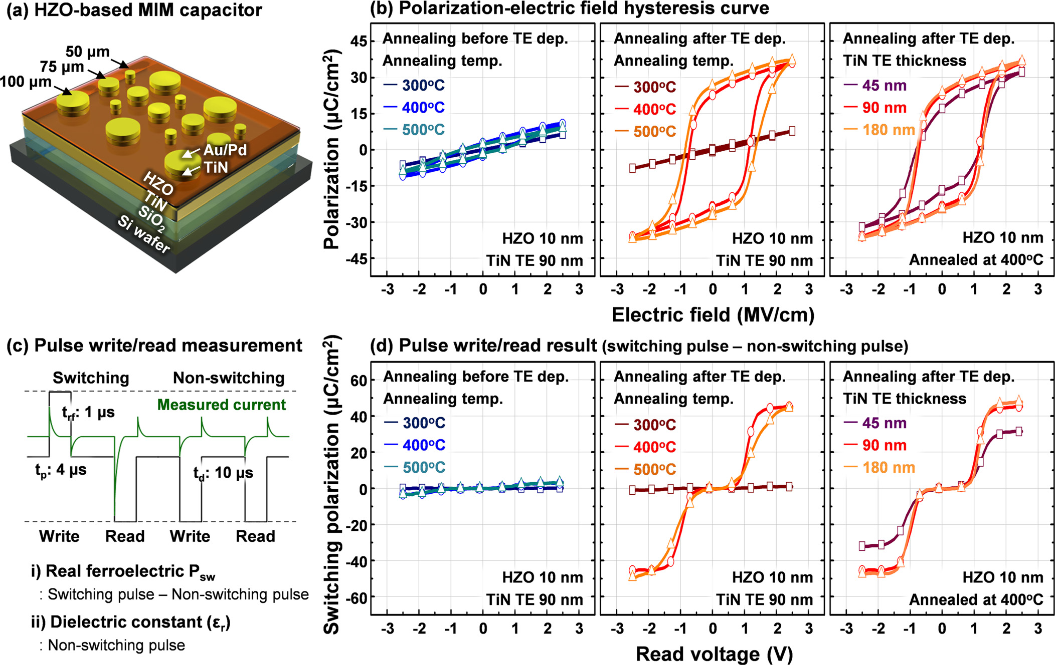

FIG. 1. (a) Schematic illustration of the 10-nm-thick HZO-based MIM capacitors. (b) Polarization-electric field hysteresis curves of 10-nm-thick HZO-based MIM capacitors after wake-up field cycling (105cycles @ 2.5 MV/cm) before and after annealing with and without a TiN TE. (c) Schematic diagram of the pulse write/read measurement. (d) Pulse write/read results of 10-nm-thick HZO-based MIM capacitors after wake-up field cycling (105cycles @ 2.5 MV/cm)

before and after annealing with and without a TiN TE.

|  |  |  |
| --- | --- | --- |
| 242901-3 | Kim et al. | Appl. Phys. Lett. 111, 242901 (2017) |

TABLE I. Comparison of the performance of 10-nm-thick HZO-based MIM capacitors used in this work.

|  |  |
| --- | --- |
| Thickness | Parameter (After 105cycles at 2.5 MV/cm) |

Non-switching polarization

|  |  |  |  |  |  |  |  |  |  |
| --- | --- | --- | --- | --- | --- | --- | --- | --- | --- |
| Type | Temp. (�C) | HZO (nm) | TiN TE (nm) | 2Pr (iC/cm2) | Psw (lC/cm2) | FE Vsat (V) | Ec (MV/cm) | er (<Ec) | er (�Ec) |
| Annealing before TiN dep. | 300 | 10 | 90 | … | … | … | … | 19.9 |  |
| 28.9 |
| Annealing after TiN dep | 400 | 10 | 90 | 6 | 3 | �2.0 �2.0 … | �1.0 �1.1 … | 30.6 | 40.8 |
| 500 | 10 | 90 | 6 | 3 | 25.4 | 32.7 |
| 300 | 10 | 90 | … | … | 20.6 | 34.7 |
| 400 | 10 | 90 | 48 | 45 | �1.5 �2.0 �1.5 �1.5 | �1.0 �1.1 �1.0 �1.0 | 45.3 | 67.2 |
| 500 | 10 | 90 | 52 | 45 | 43.7 | 57.4 |
| 400 | 10 | 45 | 35 | 32 | 49.9 | 78.8 |
| 400 | 10 | 180 | 48 | 48 | 46.9 | 60.1 |

extract the dielectric constant (er) of the film (see Table I and [supplementary material](ftp://ftp.aip.org/epaps/appl_phys_lett/E-APPLAB-111-028750)). When the read voltage is much lower than the coercive voltage, the extracted er (�Ec) is similar to the er obtained from the small signal capacitance-voltage (C-V) measurement (50 mV level) at 2.5 MV/cm where the FE switching effect is minimized.5Meanwhile, the extracted er (�Ec) at or above the coercive voltage in the non-switching pulse write/read measurement is close to the maximum er in the small signal C-V measurement at the coercive voltage, which includes a FE domain switching component due to the voltage bias sweeping. This implies that the FE switching component in the non-switching mode is attributed by FE domain reversal possibly due to the depo-larization effect during large signal measurements.

All of the HZO samples were found to exhibit a pinched hysteresis loop before wake-up field cycling (i.e., pristine state, data not shown) and FE properties after 105wake-up field cycling at 2.5 MV/cm. During the wake-up field cycling, a constricted polarization hysteresis becomes more ideal and open due to the redistribution of existing defects such as oxy-gen vacancies.16,17After wake-up field cycling, the HZO sample annealed at 400�C after TiN TE deposition exhibited large 2Pr (48 lC/cm2) and Psw (45 lC/cm2) and low FE Vsat 400�C before TiN TE deposition (2Pr of 6 lC/cm2, Psw of (�1.5 V) compared to those of the HZO sample annealed at 3 lC/cm2, and FE Vsat of �2.0 V). The origin of such a large difference will be discussed in detail later. The HZO sample

annealed at 500�C after TiN TE deposition shows a relatively high FE Vsat (�2.0 V) and leakage current properties while maintaining large 2Pr (52 lC/cm2) and Psw (45 lC/cm2). From these results, it was found that the annealing process at 400�C is required to achieve high 2Pr and Psw and should be performed after TiN TE deposition. Moreover, a TiN TE (90 nm or higher) of sufficient thickness is also required to achieve the large 2Pr and Psw as shown in Figs. 1(b) and 1(d). Notably, the obtained FE Vsat is maintained at a constant value regardless of the TiN TE thickness and is lower than that (2.5–3.0 V) of previously reported doped-HfO2 films.7,8 The resulting crystal structures of the various HZO films before and after annealing and with varying TiN TE thick-nesses are examined using an X-ray diffraction (XRD, Rigaku SmartLab) system via grazing-angle incidence XRD (GIXRD) in the 2h range of 26�–40�with an incidence angle of 0.5�as shown in Fig. 2. Before the measurements, the TiN TEs of all HZO samples are removed using SC-1 (NH4OH þ H2O2) after the annealing process. Because of the structural similarity, it is difficult to distinguish the o-phase from the tetragonal phase (t-phase, space group: P42/nmc) in the GIXRD pattern, so that the HZO peaks centered at �30.5�and�35.5�are assigned to the o(1 1 1) phase and o(2 0 0) phase, which coincides with the FE behavior. The HZO (-1 1 1) and (1 1 1) peaks from the m-phase are centered at �28.5�and�31.5�, respectively.9,18The TiN (1 1 1) peaks from the BEs centered at 36.7�(Ref. 19) are also shown in Fig. 2(a).

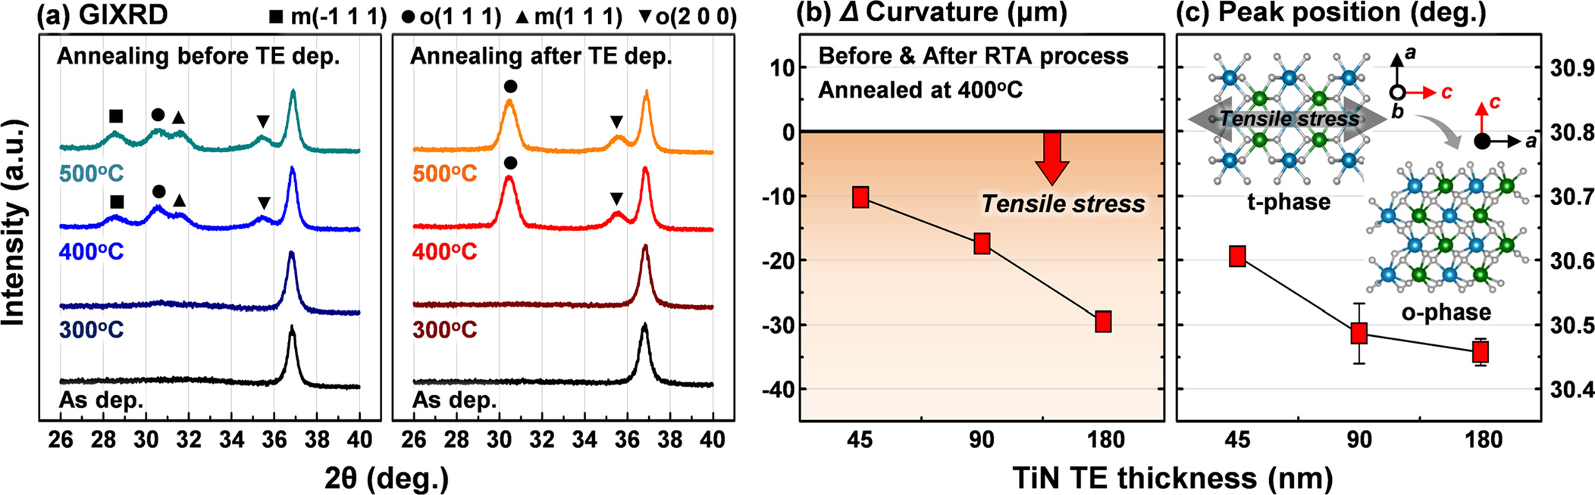

FIG. 2. (a) GIXRD patterns of 10-nm-thick HZO films: as-deposited HZO films and HZO films annealed at 300–500�C before and after TiN TE deposition. The X-ray data for the TiN capped films are taken after chemical removal of the TiN film. (b) Curvature variations of the 100 mm wafers before and after the RTA process and (c) peak position of the o-phase from GIXRD patterns as a function of TiN TE thickness.

|  |  |  |
| --- | --- | --- |
| 242901-4 | Kim et al. | Appl. Phys. Lett. 111, 242901 (2017) |

The lack of the peak definition in both the as-deposited HZO films at room temperature and the HZO films annealed at 300�C is interpreted as having an amorphous or nanocrys-talline structure. The HZO films annealed at 400�C or higher before TiN TE deposition on the other hand reveal the forma-tion of both the o-phase and the m-phase during crystalliza-tion. However, the HZO films annealed at 400�C or higher after TiN TE deposition exhibit o-phase formation with inhi-bition of m-phase formation. Assuming a Gaussian shape of GIXRD peaks from these o- and m-phases, the relative ratio of the area of o(1 1 1)/{m(-1 1 1)þo(1 1 1) þ m(1 1 1)} as a function of annealing temperature is estimated from the deconvoluted GIXRD spectra in the 2h range of 27�–33�. The relative ratio of the o(1 1 1) phase in the HZO film annealed before TiN TE deposition was 54.6% when the annealing temperature was 400�C, and it decreased to 45.3%, 42.0%, and 19.9% for annealing temperatures of 500�C, 600�C, and 700�C, respectively. On the other hand, the relative ratio of the o(1 1 1) phase in the HZO film annealed after TiN TE deposition was 100% when the annealing temperature was 400�C or higher. Figure 2(c) shows the variation in the location of the maximum peak in the 2h range of 27�–33�as a function of TiN TE thickness (i.e., mechanical stress). For the case of a 45-nm-thick TiN TE, the maximum peak position was observed near 30.6�. This means that the HZO film was crystallized with a rela-tively high portion of the HZO (0 1 1) peak from the t-phase, centered at 30.8�,20compared to the tetragonal peak presence in other HZO films used in this work. Interestingly, the ten-dency is entirely consistent with our electrical results as shown in Fig. 1 and Table I. This phenomenon, known as the“capping layer effect,” is related to the mechanical stress from the TiN TE working as a tensile stressor on the HZO film during the annealing process.21–24The mechanical stress is generally divided into two components, namely, an intrin-sic stress due to the film growth process and a thermal stress due to the difference in the coefficient of thermal expansion (CTE) between the film and its substrate.25By measuring the curvature variations of the 100 mm wafers (Toho FLX 2320-S), the estimated stress becomes larger in accordance with the TiN TE thickness and is induced as tensile stress along the in-plane direction of the HZO film [Fig. 2(b)]. Consequently, the c-axis of the t-phase can be transformed into the a-axis of the o-phase9,20which also agrees with the

present experimental observation. As the TiN TE thickness increases, the HZO peak shifts toward a lower 2h diffraction angle due to the corresponding change in phase composition [Fig. 2(c)]: the orthorhombic to tetragonal ratio increases.

Although the presence of TiN TEs during crystallization of doped-HfO2 films, especially Zr-doped films, has been demonstrated to reduce the m-phase fraction, polycrystalline films consisting of a single o-phase have not been achieved in previous reports.6–9,16–24,26A stable pre-existing m-phase cannot be transformed into the o-phase, and a portion of m-phase can be increased as a result of increasing the HZO film thickness or annealing temperature. Because the m-phase causes the degradation of ferroelectricity, inhibition of m-phase formation during the annealing process is the key to obtaining large FE polarization. Therefore, the overwhelming tensile stress generated by annealing the room-temperature deposited TiN TE is required for the crystallization of a sin-gle, non-centrosymmetric o-phase.

Figure 3 shows the cross-sectional high-resolution trans-mission electron microscopy (HR-TEM, JEOL JEM-2100F) images of the 10-nm-thick HZO-based MIM capacitor and HZO samples annealed at 400�C before and after TiN TE deposition. The diffraction spots from o(1 1 1), m(1 1 1), and m(-1 1 1) phases of HZO films are marked in fast Fourier transformation (FFT) images (data not shown). The lattice fringes in both HZO films and the directions of diffraction spots from FFT images suggest that amorphous structures are crystallized. For the case of the 10-nm-thick HZO film annealed at 400�C after TiN TE deposition, the o-phase with a crystallographic orientation along the (1 1 1) plane (a length of about 30 nm in the horizontal direction) was obtained. Using the FFT patterns and its reverse images filtered by a mask, the inter-atomic distance (d) of the enclosed area in both HZO films was measured as shown in Figs. 3(b) and 3(c). These val-ues are consistent with the d-spacing values calculated using Bragg’s law from GIXRD results in this study.

Our observations indicate that the 10-nm-thick HZO films with a 90-nm-thick TiN TE annealed at 400�C can pro-mote the formation of the o-phase (i.e., inhibit formation of the m-phase). Furthermore, the low thermal budget processes utilized in our experiments facilitate the realization of FE capacitors integrated in the BEOL for embedded smart memory applications. The parameters of HZO-based MIM capacitors obtained in this study are summarized in Table I.

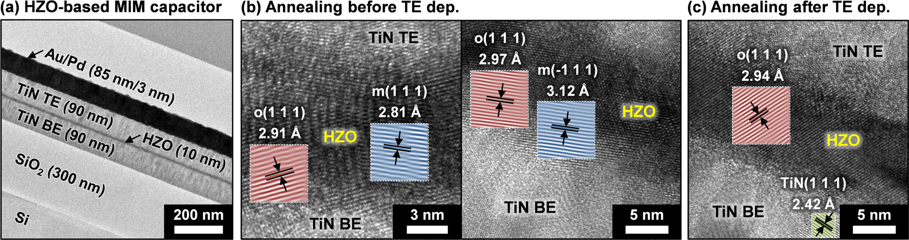

FIG. 3. (a) Cross-sectional HR-TEM images of the 10-nm-thick HZO-based MIM capacitor. HZO samples annealed at 400�C (b) before and (c) after TiN TE deposition. For better visibility, the reverse FFT images obtained from the filtered FFT images by mask are artificially colored. The inter-atomic distance of the enclosed area was measured in both HZO samples.

|  |  |  |
| --- | --- | --- |
| 242901-5 | Kim et al. | Appl. Phys. Lett. 111, 242901 (2017) |

In conclusion, we have investigated the FE properties of atomic layer deposited 10-nm-thick HZO films and the effects of the annealing temperature and TiN TE thickness (i.e., mechanical stress). After wake-up field cycling, the HZO sam-ple annealed at 400�C after TiN TE deposition showed large Psw (45 lC/cm2) and low FE Vsat (�1.5V) measured by pulse write/read measurements. Based on the results, it was con-cluded that an annealing process (as low as 400�C for 1min) is required and should be performed after TiN TE (90 nm or higher) deposition at room-temperature for the 10nm HZO crystallization to exhibit a non-centrosymmetric o-phase, which is responsible for large FE polarization. This implies that low thermal budget HZO-based FE circuits can now be integrated at the BEOL for multi-functional devices or used for various displays, especially flexible and wearable products.

See [supplementary material](ftp://ftp.aip.org/epaps/appl_phys_lett/E-APPLAB-111-028750) for the pulse write/read measurement and the extracted dielectric constant calculated from the pulse write/read measurement.

|  |  |  |  |  |  |  |
| --- | --- | --- | --- | --- | --- | --- |
| This | work | was | financially | supported | by | Texas |

Instruments. The ozone generator used in this work was provided by Toshiba-Mitsubishi-Electric Industrial Systems Corporation (TMEIC).

1Thin Film Ferroelectric Materials and Devices, edited by R. Ramesh (Springer Science & Business Media, 2013).

2A. I. Kingon, S. K. Streiffer, C. Basceri, and S. R. Summerfelt, [MRS Bull.](https://doi.org/10.1557/S0883769400035910) 21, 46 (1996).

3J. A. Rodrigues, K. Remack, K. Boku, K. R. Udayakumar, S. Aggarwal, S. R. Summerfelt, F. G. Celii, S. Martin, L. Hall, K. Taylor, T. Moise, H. McAdams, J. McPherson, R. Bailey, G. Fox, and M. Depner, [IEEE Trans. Device Mater. Reliab.](https://doi.org/10.1109/TDMR.2004.837210) 4, 436 (2004).

4H. P. McAdams, R. Acklin, T. Blake, X.-H. Du, J. Eliason, J. Fong, W. F. Kraus, D. Liu, S. Madan, T. Moise, S. Natarajan, N. Qian, Y. Qiu, K. A. Remack, J. Rodriguez, J. Roscher, A. Seshadri, and S. R. Summerfelt, [IEEE J. Solid-State Circuits](https://doi.org/10.1109/JSSC.2004.825241) 39, 667 (2004).

5S. J. Kim, D. Narayan, J.-G. Lee, J. Mohan, J. S. Lee, J. Lee, C. D. Young, J. Kim, S. R. Summerfelt, T. San, and L. Colombo, in Proceedings of the 9th IEEE International Memory Workshop (IMW) (2017).

6T. S. B€oscke, J. M€uller, D. Br€auhaus, U. Schr€oder, and U. B€ottger, [Appl. Phys. Lett.](https://doi.org/10.1063/1.3634052) 99, 102903 (2011).

7J. M€uller, T. S. B€oscke, S. M€uller, E. Yurchuk, P. Polakowski, J. Paul, D.

Seidel, A. Kumar, T. M. Arruda, S. V. Kalinin, T. Schl€osser, R. Boschke, R. van Bentum, U. Schr€oder, and T. Mikolajick, in Proceedings of the 59th IEEE International Electron Devices Meeting (IEDM) (2013), p. 10.8.1.

8S. Mueller, S. R. Summerfelt, J. M€uller, U. Schroeder, and T. Mikolajick, [IEEE Electron Device Lett.](https://doi.org/10.1109/LED.2012.2204856) 33, 1300 (2012).

9M. H. Park, H. J. Kim, Y. J. Kim, T. Moon, and C. S. Hwang, [Appl. Phys. Lett.](https://doi.org/10.1063/1.4866008) 104, 072901 (2014).

10J. E. Lowther, J. K. Dewhurst, J. M. Leger, and J. Haines, [Phys. Rev. B](https://doi.org/10.1103/PhysRevB.60.14485) 60, 14485 (1999).

11T. D. Huan, V. Sharama, G. A. Rossetti, Jr., and R. Ramparasad, [Phys.](https://doi.org/10.1103/PhysRevB.90.064111)  [Rev. B](https://doi.org/10.1103/PhysRevB.90.064111) 90, 064111 (2014).

12R. Materlik, C. K€unneth, and A. Kersch, [J. Appl. Phys.](https://doi.org/10.1063/1.4916707) 117, 134109 (2015).

13J. M€uller, T. S. B€oscke, D. Br€auhaus, U. Schr€oder, U. B€ottger, J. Sundqvist, P. K€ucher, T. Mikolajick, and L. Fery, [Appl. Phys. Lett.](https://doi.org/10.1063/1.3636417) 99,

|  |  |  |  |  |  |  |  |  |
| --- | --- | --- | --- | --- | --- | --- | --- | --- |
| 112901 (2011). | | E. | Suborova, | M. | Spiridonov, | D. | Negrov, | A. |
| 14S. | Zarubin, |

Chernikova, A. Markeev, and A. Zenkevich, [Appl. Phys. Lett.](https://doi.org/10.1063/1.4966219) 109, 192903 (2016).

15S. J. Kim, J. Mohan, J. S. Lee, H. S. Kim, J. Lee, C. D. Young, S. R. Summerfelt, T. San, L. Colombo, and J. Kim, “Stress-induced crystalliza-tion of thin Hf1-XZrXO2 films: The origin of enhanced energy density with minimized energy loss for lead-free electrostatic energy storage applications” (unpublished).

16S. Starschich, S. Menzel, and U. B€ottger, [Appl. Phys. Lett.](https://doi.org/10.1063/1.4940370) 108, 032903 (2016).

17M. Pe�sic´, F. P. G. Fengler, L. Larcher, A. Padovani, T. Schenk, E. D. Grimley, X. Sang, J. M. Lebeau, S. Slesazech, U. Schroeder, and T. Mikolajick, [Adv. Funct. Mater.](https://doi.org/10.1002/adfm.201600590) 26, 4601 (2016).

18J. M€uller, T. S. B€oscke, U. Schr€oder, S. Mueller, D. Br€auhaus, U. B€ottger, L. Frey, and T. Mikolajick, [Nano Lett.](https://doi.org/10.1021/nl302049k) 12, 4318 (2012).

19N. K. Ponon, D. J. R. Appleby, E. Arac, P. J. King, S. Ganti, K. S. K. Kwa, and A. O’Neill, [Thin Solid Films](https://doi.org/10.1016/j.tsf.2015.02.009) 578, 31 (2015).

20M. H. Park, H. J. Kim, Y. J. Kim, W. Lee, T. Moon, and C. S. Hwang, [Appl. Phys. Lett.](https://doi.org/10.1063/1.4811483) 102, 242905 (2013).

21T. Shiraishi, K. Katayama, T. Yokouchi, T. Shimizu, T. Oikawa, O. Sakata, H. Uchida, Y. Imai, T. Kiguchi, T. J. Konno, and H. Funakubo, [Appl. Phys. Lett.](https://doi.org/10.1063/1.4954942) 108, 262904 (2016).

22T. Nishimura, L. Xu, S. Shibayama, T. Yajima, S. Migita, and A. Toriumi, [Jpn. J. Appl. Phys., Part 1](https://doi.org/10.7567/JJAP.55.08PB01) 55, 08PB01 (2016).

23A. Chernikova, M. Kozodaev, A. Markeev, Y. Matveev, D. Negrov, and O. Orlov, [Microelectron. Eng.](https://doi.org/10.1016/j.mee.2015.04.024) 147, 15 (2015).

24S. Mueller, J. Mueller, A. Singh, S. Riedel, J. Sundqvist, U. Schroeder, and T. Mikolajick, [Adv. Funct. Mater.](https://doi.org/10.1002/adfm.201103119) 22, 2412 (2012).

25C. T. Chuang, C. K. Chao, R. C. Chang, and K. Y. Chu, [J. Mater. Process.](https://doi.org/10.1016/j.jmatprotec.2007.11.258)  [Technol.](https://doi.org/10.1016/j.jmatprotec.2007.11.258) 201, 770 (2008).

26T. Shimizu, T. Yokouchi, T. Oikawa, T. Shiraishi, T. Kiguchi, A. Akama, T. J. Konno, A. Gruverman, and H. Funakubo, [Appl. Phys. Lett.](https://doi.org/10.1063/1.4915336) 106,

Martin, T. Schenk, K. Khullar, A. Kersch, W. Weinreich, S. Riedel, K. 112904 (2015).